Machine Description | The Atlas server in this beginner room covering Windows attack methodology. Made for beginners to learn how to approach windows target machine.
Target IP | 10.201.10.108
Vulnerability Name | CVE-2019-17662 — ThinVNC / VNC credentials disclosure vulnerability
Service / Version | TCP / 8080 HTTP
CVSS Score / Severity | 8.8 High
Attack Vector | CVSS:3.0/AV:N/AC:L/PR:L/UI:N/S:U/C:H/I:H/A:H
Proof Of Concept | Step 1 – Adding Target IP to local host’s file  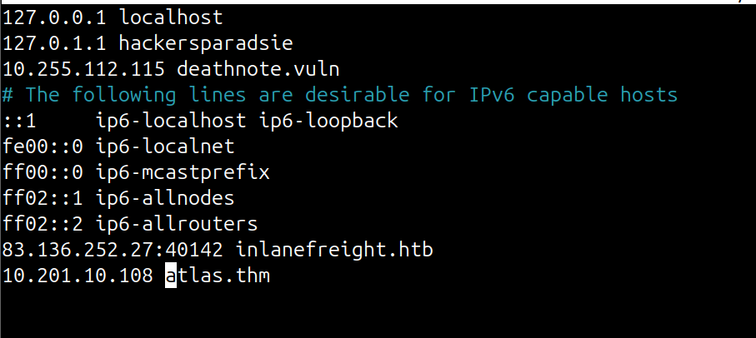  STEP 2 – Scanning target for the open ports using Nmap  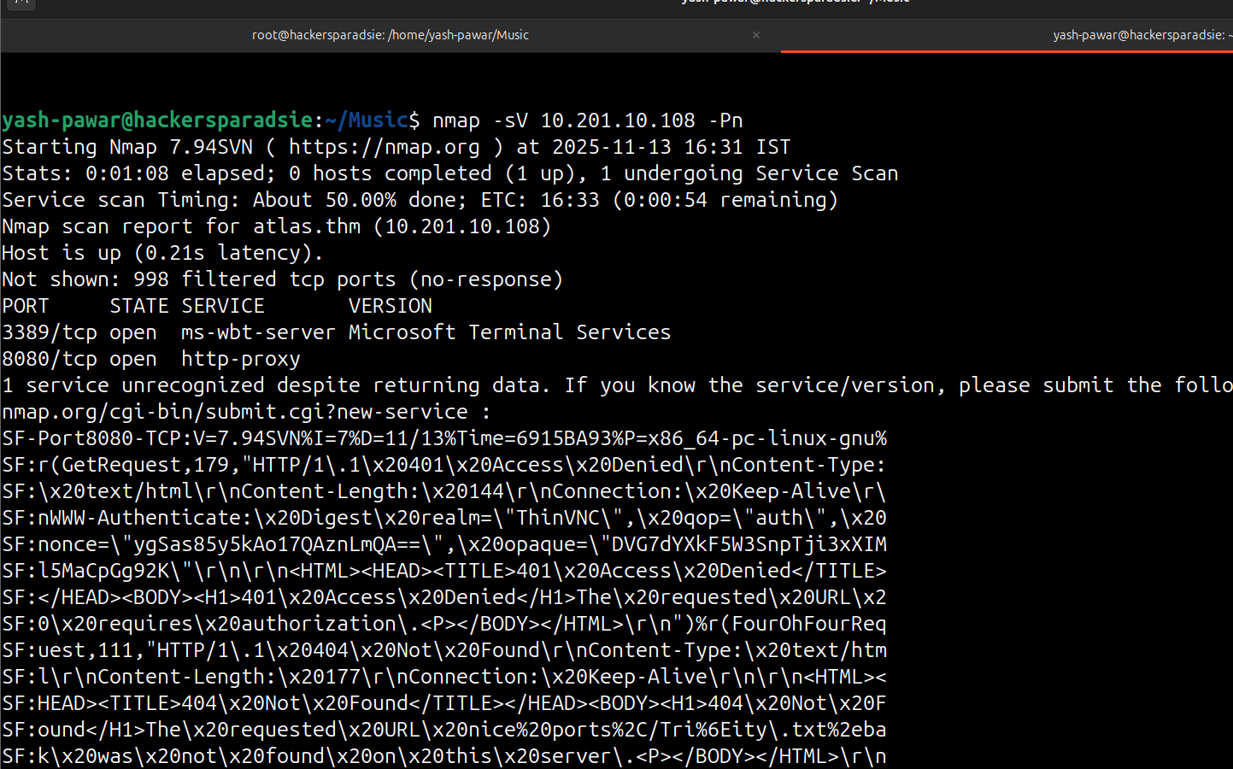  STEP 3 – Enumerating Port 8080 HTTP  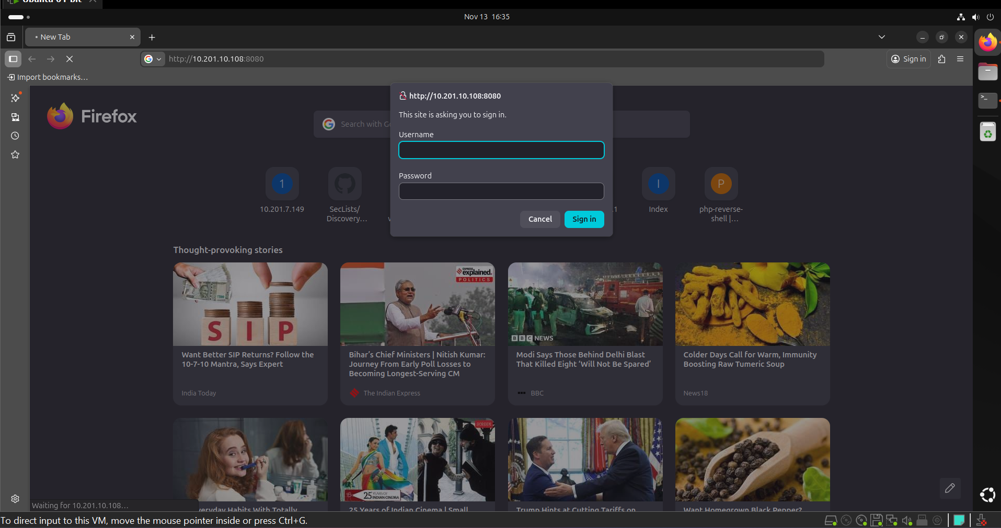  - There is some kind of basic authentication running on the target  - Its running Some kind of ThinVNC on 8080 which is discovered by nmap  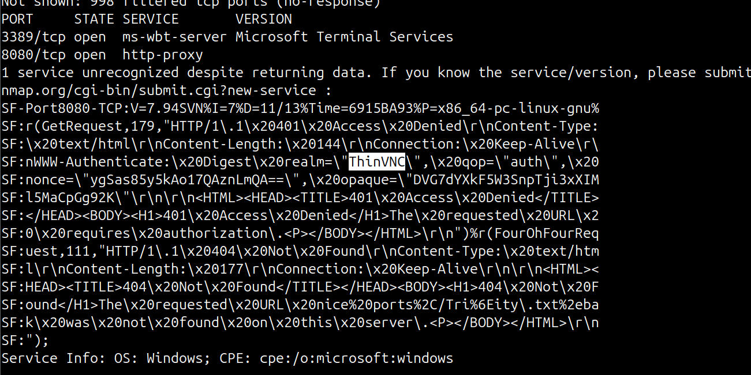  STEP 4 – Lets try to find if we have any thing on Exploit DB  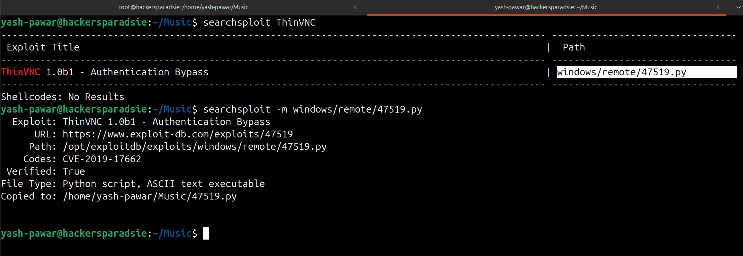  So we do have an Exploit relevant to the Service  STEP 5 – Run the Exploit  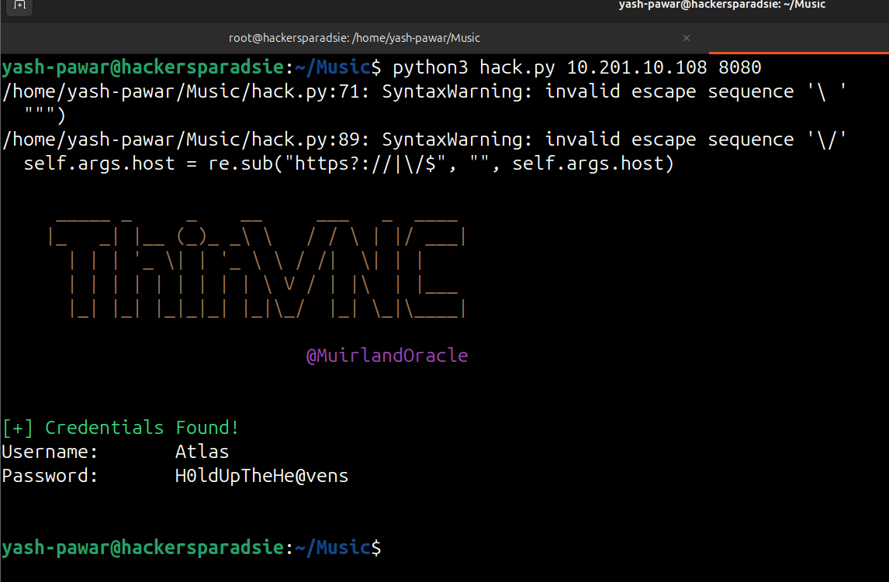  - We got Creds try to auth on server  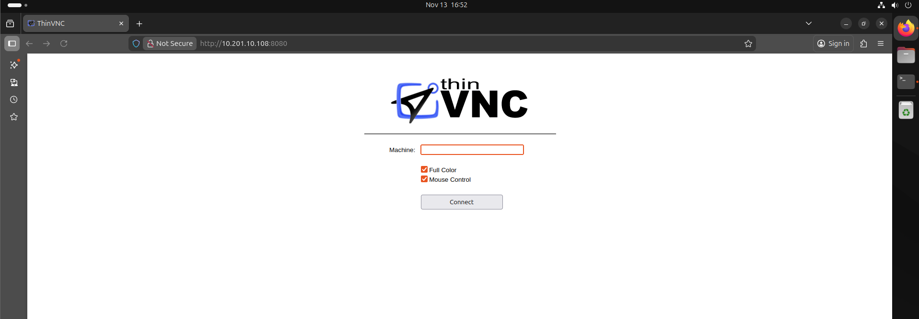  - We got login here  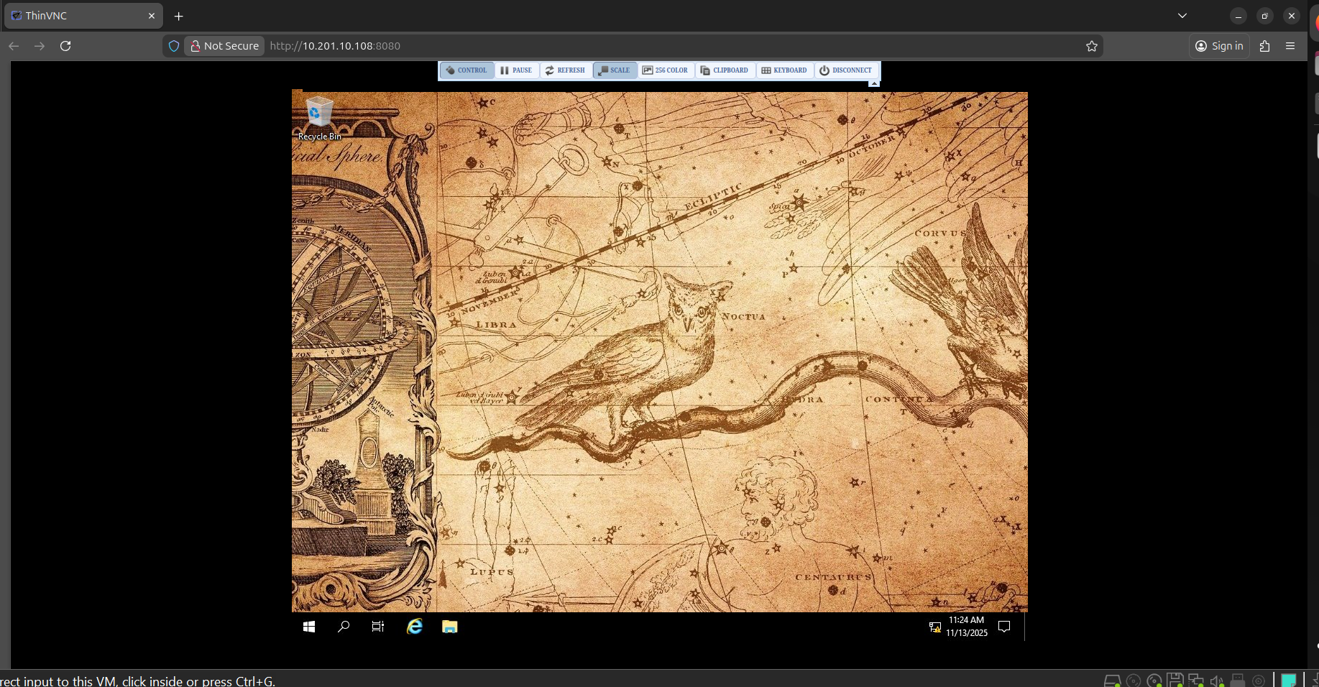  We got Access of machine We can even try RDP access using XFREERDP
Impact | - Attacker can obtain valid login credentials via exposed ThinVNC service and access desktop remotely.  - With user access, attacker leverages PrintNightmare exploit to escalate to SYSTEM/root privileges.  - Full host compromise allows attacker to access sensitive data, network pivoting, install persistent backdoors.  - Windows host becomes a beachhead for lateral movement in the network.
Remediations | - Disable or restrict ThinVNC service (bind to localhost or internal network only), change default credentials, update to fixed version.  - Apply latest Microsoft patches for the Print Spooler vulnerability (as per MS advisory) and disable inbound Print Spooler if not required.  - Restrict service access via firewall rules, implement network segmentation for remote desktop services.  - Monitor logs for unusual VNC or print spooler activity, enforce least-privilege on user accounts and disable unnecessary services.
Reference | https://tryhackme.com/room/atlas

